Background
Our product is developed by i*CATch toolkit for a learning room of orchestra/band in a music/art museum, users can feel the sound of different instrument and try different combinations to feel what the sound of orchestra/band will looks like without knowing how to play any instrument.

The following would be the outlook of our product design
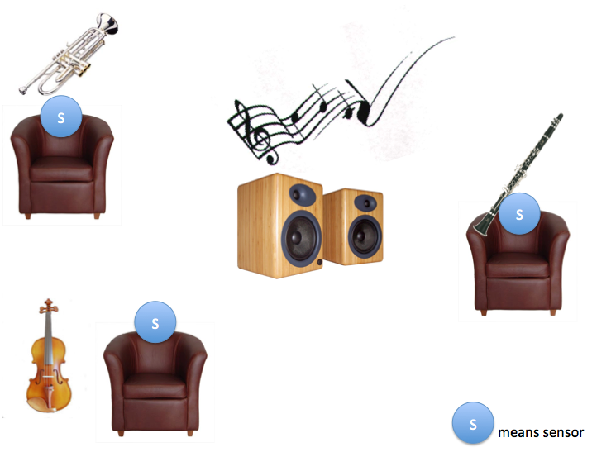
How the people interact with our system?
Once a user take a seat, the sensor will sense someone sitting in, then a sound track of that instrument (e.g. piano)will play out from the speaker; When more and more user sitting in different seat, the different instrument combination will play together.

How much space do we need?
More then 20m² room with a desk and 3 chairs around

System Hardware Specification:
- iCatch x 3
- Power supply set x 3
- Light sensor x 3
- LED matrix x 3
- Zigbee connector x 3
- Personal Computer x 1

